FOEGL Newsletter

August/September 2015

A Letter from FOEGL President Sally Cashin

“I love libraries because they expect little but give much.”

- Dennis Gaffney, author of “Why I love Libraries”

Libraries are unassuming; open shelves and kind, knowing librarians encourage exploration. Libraries are welcoming to all inquisitive minds and lifelong learners.

Libraries are magical; children travel to fantasy worlds and adults are free to ponder.

I love our Library.

Whether young, old, or somewhere in between, I hope your summer involved some wandering in the Library. FOEGL volunteers were hard at work to help our Library grow! You may have noticed the beautiful gardens flanking the Library’s entrance -- carefully tended by FOEGL volunteers, “book worms” as we like to call them -- and expanded this summer with the generous donation of perennials from Chris Fehlhaber of Northwind Perennial Farm. Thanks also to co-chairs Kristina Olkowski and Megan Sayas for another successful Bookie Cookie Sale raising $1,387.

In June, FOEGL proudly presented the Library with a check for $17,000, funds raised from the annual Used Book Sale. With this money, the Library plans to purchase children’s books and audiobooks, special shelving in children’s area to hold all these new collections, adult books and audiobooks, as well as a new Blu-ray collection. In addition, $500 will be used for adult programing -- a new collaborative effort between the Library and FOEGL.

This summer approximately 1,500 children participated in various children’s programs at our Elm Grove Library! The Friends of the Elm Grove Library continue to support these summer programs by covering the cost of the performers, craft materials, and even the beloved popcorn. We love inspiring a future generation of readers!

A few thing to look out for this fall: The “Newcomers & Neighbors Book Group,” organized by Judy Giljohann, will be meeting September 24th, and our 8th annual Elm Grove READS, an evening with author Jane Hamilton, is set for October 8th. Tickets are now on sale! Additional details on these two programs, and the many other fall programs offered at the Library, are provided within this newsletter.

Finally, the Elm Grove Library Board recently completed solicitation of its Strategic Planning Survey. Thank you to all who participated. This fall we will be learning the direction of the board’s Strategic Planning. FOEGL will incorporate these results to further grow and support our Library.

As we look forward to hearing the feedback provided in the survey I anticipate one common theme… “We love our Library!” ~Sally Cashin

2015 – 2016 FOEGL OFFICERS

**Board of Directors**

**President**: Sally Cashin

**1st Vice-President**: Kathy Baptie

**2nd Vice-President**: Pat Tibbetts

**Secretary**: Karen Sopik

**Treasurer**: Carla Stensberg

**Members-At-Large:**

**2 Year Term:** Deb Flanigan & Judy Giljohann

**1 Year Term:** Jan Cronin & Maureen Ullrich

**Committee Chairs**

**Adult Programs:** Kathy Baptie

**Book Discussion**: Judy Giljohann

**Bookie Cookie**: Megan Sayas & Kristina Olkowski

**Children’s Programs**: Julie Malloy

**Elm Grove Reads**: Kathy Baptie

**Exhibits and Displays**: Teena Flanner

**Gifts and Bequests/Lights of Love:** Amy Fotsch, Jill Varick, & Maureen Ullrich

**Historian**: Mary Gayle Gagliano

**Hospitality**: Sue Jablonski & Kathy Fuhr

**Membership/Volunteers**:Pat Tibbetts

**Newsletter**: Kathy Cavalco

**Publicity**: Janet Wintersberger

**Strategic Planning (Ad Hoc)** Betsy Haushalter

**Used Book Sale**: Pat Ruttum, Kathy Baptie, Karen Dahlman,

Jane Kivlin, Connie Pavletich, Carla Stensberg,

Kathy Tusing & Janet Wintersberger

**Web / Social Network**: Mary Shanahan

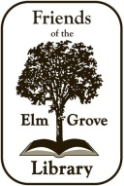

2015 - 2016 FOEGL MEMBERSHIP

The FOEGL membership year is off to a strong start! Sincere appreciation to all of our returning members and a warm welcome to our new members! We thank all of you who realize the importance of having a strong and viable public library and its place as an invaluable community resource.

We still have a number of members who have not returned their renewal forms and dues for the upcoming year. If you haven’t renewed your FOEGL membership yet, please consider doing so. If you’re not sure if you renewed or not, send me an e-mail and I’ll let you know (ptibbetts@wi.rr.com). Non-renewing members will be dropped from our mailing lists after this newsletter.

We have new life members – Allan Kasprzak and Trudi Schmitt. Allan and Trudi have been significant supporters of the library over the years and now they have become life members. FOEGL offers its sincere thanks to Allan and Trudi for their generous gift.

Listed below are our current members. Those names with an * denote new members.

Respectfully,

Pat Tibbetts

Membership chairman

ptibbetts@wi.rr.com

***Life Members***

Suzanne Belson Karen Chamberlain Bernadette DeMuri

Bob & Toni Gorske Dave & Marge Hamacher Allan Kasprzak & Trudi Schmitt Rebecca & Richard Leiviska Gwen & Bob Medved Sheila Reynolds & Bob Chang

Helen Ring Rich & Ann Teerlink Bonnie Welz

***Patrons***

John & Sue Alexander Neal & Carla Butenhoff Dave & Jan Cronin

David & Pat Rierson Carla Stensberg

***Business***

Charles Roy

***Family***

Ginny Anderson Debra Baeseman & Nick Pedriana Jean Baesemann

Lynn Barlow Sue & Al Bohon Tom Brown

John & Kathleen Cantieri Pat & Sally Cashin Tony & Kathy Cavalco

Dan & Annette Cleary Karen & Joe Dahlman Jeff & Laurie Derus

Mark & Julie DiFonzo Ruthann Driscoll David & Margaret Dunn

Ed & Ann Duthie Karen & John Finerty Deb Flanigan

John Galanis Bonnie & Don Groff Mindy Harmelink*

Betsy & Bob Haushalter Monica & Jeff Hughes George & Valeri Huhnke

Sue & Francis Jablonski Joanne & Irwin Johnson Jean Kelly

Jane Kivlin & Tom Kelly Bonnie & Jim Klamik William & Gordanna Komassa

John & Mary Krebs Bill & Judy Laste Pat & Fran Lavin

John & Pat Loebl Dr. Ron & Kay Martins Brian & Elizabeth Naylor

Dave & Sally Neeb Bob & Kay Noel Neil Palmer & Jill Varik

Marilynn Rennebohm Mary & Bernie Rhomberg Vic Rojek

2015 - 2016 FOEGL MEMBERSHIP - *continued*

***Family***

Pat & Mark Ruttum John & Barbara Schaefer Michael & Karen Scherbel

Curtis & Marieta Scherer Harry & Ellie Schroeder Gary & Nancy Seabrook

Mary & Jim Shanahan Patricia Siberz Judy & Frank Siebrecht

Shani Sinson Ted & Barbara Steiner Sibylle Tasker

Kathy & Jim Tusing Mike & Maureen Ullrich Joan Uselmann*

Nancy Vetter Jim & Michelle Wallace Ronald & Agnes Wells

Greg & Nancy Wilde

***Individual***

Ilze Balodia-Larson Geraldine Banaszak Tessa Bartels*

Dorothy J. Beck K. Joanne Benes Janice Beyer

Therese Bohn Sue Brill Joyce Broderick

Ardene Brown Pauline Bruce Mary Ellen Buellesbach

Mary Cain Brenda Campbell Marcia Clafford

Linda de la Mora Mary De Vita Rita G. Denny

Ann Deuster Dougherty Dorothy Dieter Lynn Doyle

Helen Ericksen Nancy Eschenburg Nancy Fennell

Nancy Ferguson Catherine Fink Lucille Fischer

Teena Flanner Rachel Formolo Amy Fotsch

Maryann Fricker Kathleen Fuhr Beverly Fula

Mary Gayle Gagliano Karen George Judy Giljohann

Kathi Glick Robert Gricunas Betty Groskopf

Linda Grunau* Lilly Harris* Nancy Hart

Mary Hay and David Hay Phyllis Hoyer Judy Islo

Suzanne Janke Judy Jankowski Mary Johnson*

Karen Jungbluth Nancy Jurss Christa Katz

Doris Kaun Mary Lou Kennedy Cathy Kobs

Monica Krause Mary Kunze Kerstin Lanser

Maureen McMahon Chrissie Monday* Sarah Muench

Carl Muezmaier* Catherine Newbauer Ann Owen

Lisabeth Passalis-Bain Constance M. Pavletich Jeanne Pedriana*

Jean Phelan Doris Price Rosalind Marie Raasch

Mary Reinhart Mary Reimer Karen Rolandi

Linda Rosandich Catherine Rynkiewicz Judy Sayas

Ruthann Schindler Nick Schroeder Connie Schwaab

Joan Schwai* Susan Schweda Cathy Steele

Mary Ann Stiglitz Marilyn Sullivan Frances Taube

Pat Tibbetts Fran Tollefson Pauline Vavra

Nancy Wagner* Mary Weller Janet Wintersberger

Barbara Yug Jo Zimny

GARDEN FRIENDS

**Friends of Elm Grove Library keep our garden - and Library - growing!**

In 2010 a few of us asked Irwin Johnson to help us design a small garden to beautify the front of the Library. Irwin came up with a design, donated plants and saw to the implementation of it all. He has been our design guru for five years and the garden grew each year in different ways. A small crew of us watered and weeded and taken care of it. We cannot thank Irwin enough for all he has done these past five years.

Now we're betting you noticed the new look of the Library garden growing this summer. Chris Felhaber from Northwind Perennial Farm in Burlington, Wisconsin donated the plants and his time to develop it for us. Elm Grove can claim him as a native son and he is giving back to his community. He works for Roy Diblik who owns Northwind Perennial Farm and is known as a perennial plant expert, grower, designer, speaker and author. [Some of you will know him from the Lurie Gardens, Art Institute or Shedd Aquarium in Chicago.]

You will see amsonia 'Northwind Select', calamintha nepeta, stachys hummelo, turtlehead [chelone], coneflower, agastache 'Blue Fortune', sesleria, and allium growing around the new Cornelian cherry tree planted in April by Ron Wood, Village forester. Ron put in the hydrangeas in front of the windows last fall. With all the rain in spring, the plants took off.

If you want to explore perennial gardening more, check out the Library copy of ***The Know Maintenance Perennial Garden*** by Roy Diblik [635.932 Dib]. Chris donated a copy to our Library.

One wonderful benefit of this garden has been all the pollinators we have seen flying in and out all summer. We read so much about bees being in jeopardy but all pollinators need flowers and we provided new ones for them.

We are so fortunate to have Irwin and Chris in our community and to benefit from their experience!

ELM GROVE READS 8 - OCTOBER 8

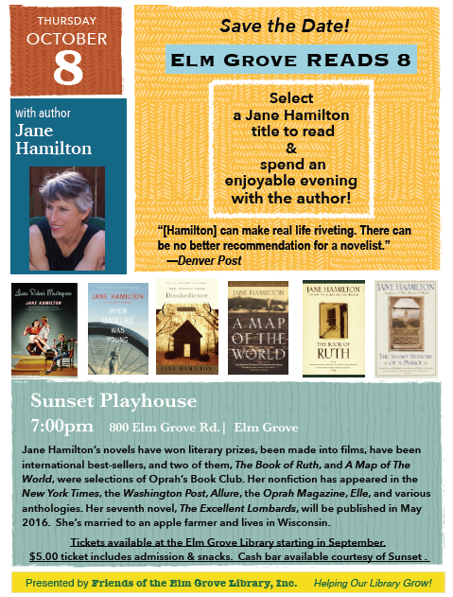

OCTOBER PROGRAM – MADE IN MILWAUKEE

**John Gurda: Made in Milwaukee**

**Thursday, October 15, 2015**

**6:30 p.m., O’Neill Room**

**From beer to gears, and hides to Harleys, an illustrated look at the evolution of our region’s economy.**

Don’t miss the first event in the Bonnie Ornst Memorial Speaker Series.

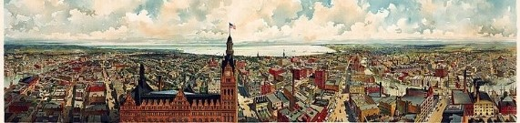

CHILDREN’S PROGRAM – UP AND ADAM

**UP AND ADAM!**

**Saturday, October 24**

****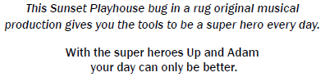**10:00 a.m.**

Good Morning!

It’s time to get going.

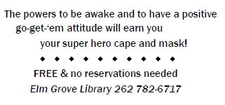How do you feel today?

**Elm Grove Library, Lower Level**

NOVEMBER PROGRAM – GENEALOGY FOR EVERYONE

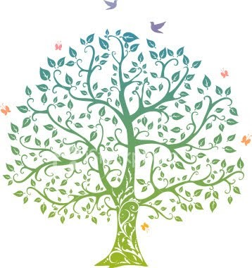

**Geneology for Everyone**

Presented by Dorothy Boxhorn, education chair of

The Waukesha County Genealogical Society.

**Thursday, November 12, 6:30 p.m.**

**O’Neill Room, Elm Grove Library**

**Learn how to get started, where to look, and**

**How easy and accessible genealogy can be.**

**Excellent for those interested in getting**

**Started and for those who have begun the**

**Process but are always on the lookout for**

**new ideas. All attendees will also receive a**

**handout to take home, full of helpful tips**

**and information.**

**Free to Attend**

**No Registration Needed**

**Great for Beginners**

**Get New Tips and Fresh Approaches**

**Discover the Fun and Rewarding**

**Endeavor of Tracing you Lineage**

USED BOOK SALE – FALL 2015 REPORT

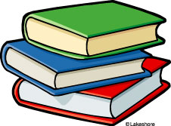

It's fall and time to clean those bookshelves! We’ve had a good number of donations this summer and we look forward to collecting and sorting additional items this fall. As always, we take books, vinyl, CDs, DVDs and cassettes. Please….no textbooks unless they are recent. You can recycle old textbooks in your home recycling container. Mark your calendars for the start of the Used Book Sale on Thursday March 3, 2016 and continuing through the weekend. The sale will feature new ideas that you'll be sure to enjoy. Also, don’t forget to shop our Mini-Book Sale on Saturday, November 14th in the Library Entrance Hallway from 10:00 a.m. to 2:00 p.m.

We've had trouble lately with donations being placed in the Library book drops outside. We ask that you bring your donations into the Library and not put them in the book drops. The book drops fill up on weekends and it's confusing to tell a returned Library book from a donation. Thanks for your cooperation.

LIGHTS OF LOVE – SAVE THE DATE!

**Not Too Soon to Think Lights of Love!**

Mark your calendar now for the 21st Annual Lights of Love event on Sunday, December 6! This annual fundraiser for the Elm Grove Library will include an afternoon of fun at the Library, with crafts for the kids, stories with Mrs. Claus (new this year!), a visit from Santa, a special Lionel train exhibit and a stringed quartet playing holiday music.

The event culminates with the tree lighting outside Village Hall followed by refreshments in the Courtroom. More details to come!

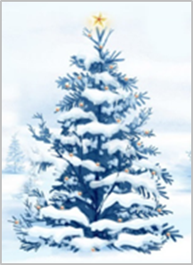

CHILDREN’S PROGRAMS 2015 - 2016

Children love the programs offered at the library. During the 2015-2016 program year, the children will once again enjoy a *bug in a rug* Theatre production from Sunset Playhouse, the just-for-kids activities during the Lights of Love celebration on December 6, and a visit with the 'Mad Scientist' himself.

We can't wait to provide more details. The programs are free and open to the public.

FOEGL BOOK CLUBS / DISCUSSION GROUPS

**FOEGL currently has four book clubs: The Bibliomaniacs Book Club, The Once and Future Book Club, The Young and the Rest of Us Book Discussion Group, and new this year, The Newcomers & Neighbors Book Club.**

**Individuals who would like to join an existing FOEGL book group or form a new book discussion group should contact Judy Giljohann at** jsgilly@gmail.com **for additional information.**

**Join Us! New Members Are Welcome!**

**The Bibliomaniacs Book Club**

**Meets:** Third Wednesday of the month, September – May (except December)

**Time:** 10:00 a.m.

**Location:** Park View Room, Elm Grove Village Hall

**Contact Person:** Connie Pavletich (262) 786-4775 pavcd@wi.rr.com

**Schedule:**

**September 16, 2015**

Book: *Galway Bay* by Mary Pat Kelly

Leaders: Maureen McMahon and Fran Lavin

**October 21, 2015**

Book *All the Light We Cannot See* by Anthony Doerr

Leader: Connie Pavletich

**November 18, 2015**

Book *Light Between Oceans* by N.L. Stedman

Leaders: Mary DeVita and Geri Erickson

**January 20, 2016**

Book *Me Before You* by Jojo Moyes

Leaders: TBD

**February 17, 2016**

Book *Citizens of London* by Lynne Olson

Leader: Phyllis Hoyer

**March 16, 2016**

Book *The Boys in the Boat* by Daniel James Brown

Leaders: TBD

**April 20, 2016**

Book *The River of Doubt* by Candace Millard

Leaders: TBD

**May 18, 2016**

Planning meeting



FOEGL BOOK DISCUSSION GROUPS - *continued*

**The Once and Future Book Group**

**Meets**: Fourth Wednesday of the month (except in November and December)

**Time**: 7:00 p.m.

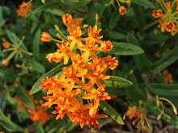**Location**: Park View Room, Elm Grove Village Hall

**Notes**: No need to contact in advance; come ready to discuss!

**Schedule:**

**September 23, 2015**: *The Biographer’s Tale* by A.S. Byatt

**October 28, 2015:** *A Man Called Ove* by Fredrik Backman

**November 18, 2015:** *The Invention of Morel*by Adolfo Bioy Casares *(Third Wednesday due to Thanksgiving.)

Future dates to be determined

**“THE YOUNG AND THE REST OF US” Book Discussion Group**

**Meets:** Second Thursday of the month

**Time:** 1:00 p.m.- 2:00 p.m.

**Location:** Park View Room, Elm Grove Village Hall

**Contact Person:** Betsy Haushalter (262) RBHaus@aol.com

**Schedule:**

**September 10, 2015**: *1984*by George Orwell

**October 8, 2015**: *Just Mercy*  by Bryan Stevenson

**November 12, 2015**: *Pure*by Andrew Miller

**February 11, 2016**: *The Sound and the Fury* by William Faulkner

**March 10, 2016**: *An Unnecessary Woman*by Rabin Alameddine

**April 14, 2016**: *All the Light You Cannot See*by Anthony Doerr

**May 14, 2016**: *The Razor's Edge* by *W Somerset Maugham*

**June 11, 2016**: Planning Luncheon –Details to be announced

`

**Love to read? Want to meet your neighbors?**

Join the Newcomers & Neighbors Book Club!

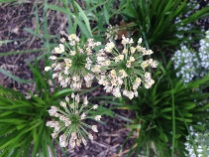Organizational meeting to be held –

**Elm Grove Village Hall**

**Park View Room**

**7:00p.m., Thursday**

**September 24, 2015.**

Contact Judy Giljohann with questions or to confirm attendance: [jsgilly@gmail.com](mailto:jsgilly@gmail.com)

**Friends of the Elm Grove Library

13600 Juneau Boulevard

Elm Grove, WI 53122

EVENT CALENDAR

October 8 7:00 p.m. Elm Grove READS 8: Author Jane Hamilton

Sunset Playhouse

October 15 6:30 p.m. John Gurda: Made in Milwaukee

O’Neill Room

October 24 10:00 a.m. Up and Adam

Elm Grove Library Lower Level

November 12 6:30 p.m. Genealogy for Everyone

O’Neill Room

November 14 10:00 a.m. – 2:00 p.m. Mini Book Sale

. Library Entrance Hallway

December 6 TBA . Lights of Love

More details to follow

**FOEGL MISSION STATEMENT**

The purpose of the Friends of the Elm Grove Library shall be to maintain an association of persons interested in books and libraries, to focus public attention on Library services, facilities and needs, and to stimulate gifts of books, magazines, desirable collections, endowments and bequests.